Requirement 1:
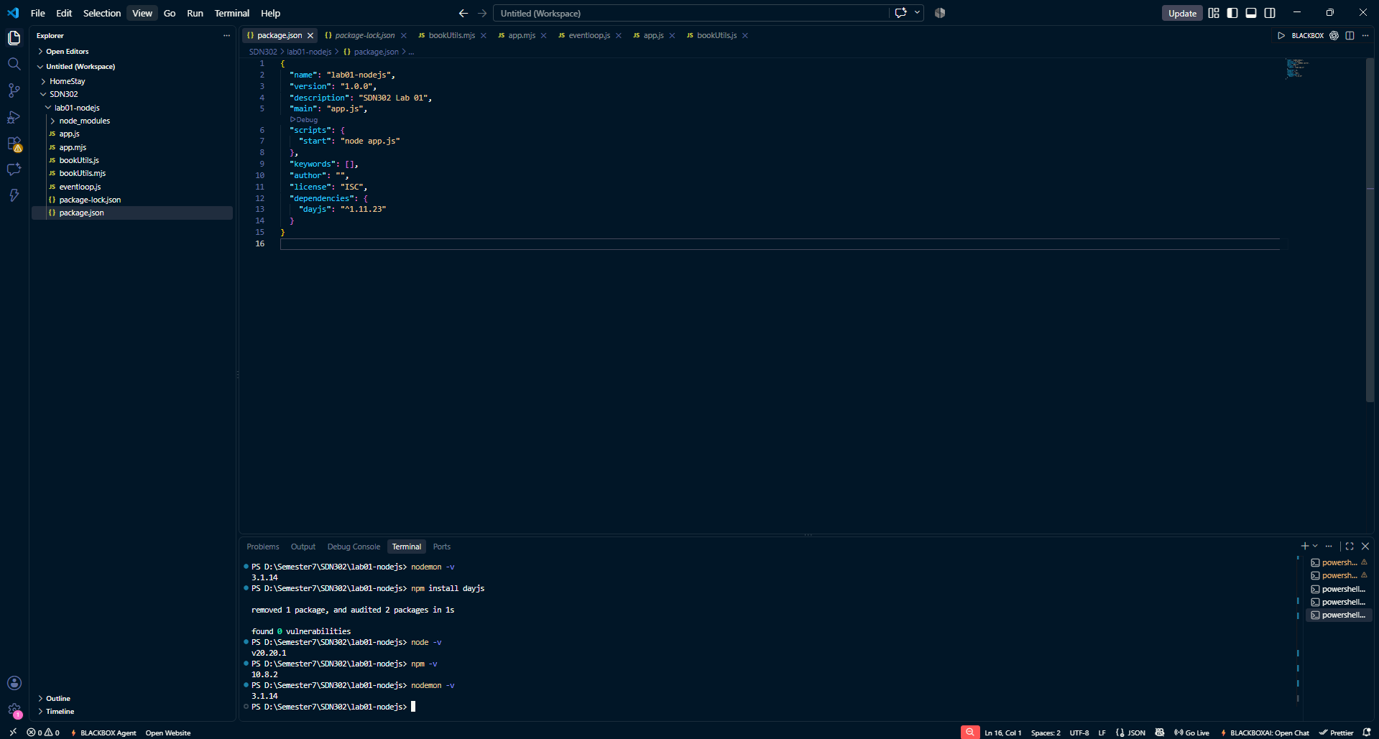
Requirement 2:
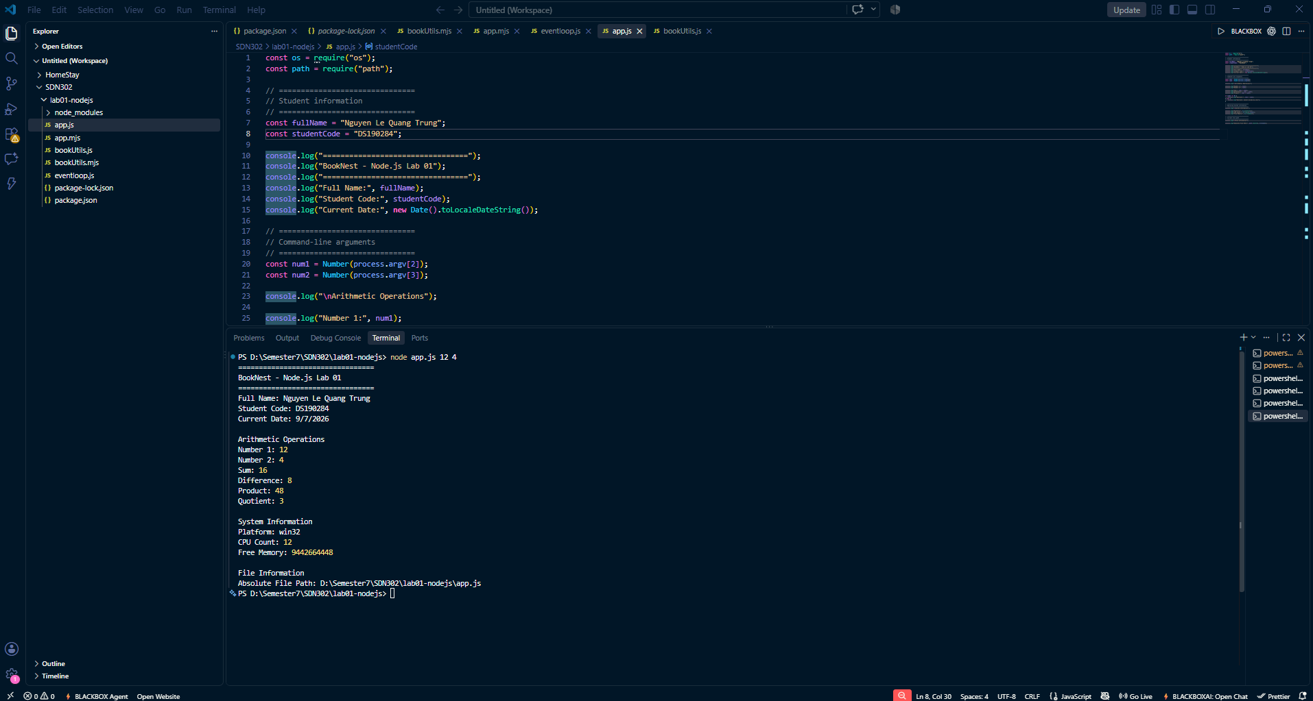
Requirement 3:
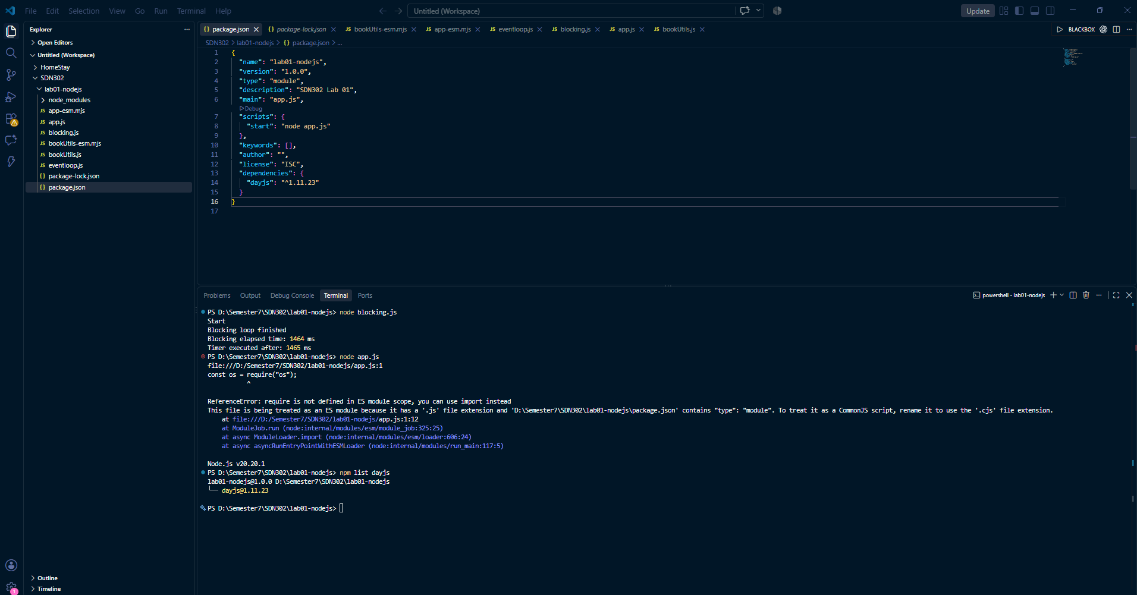
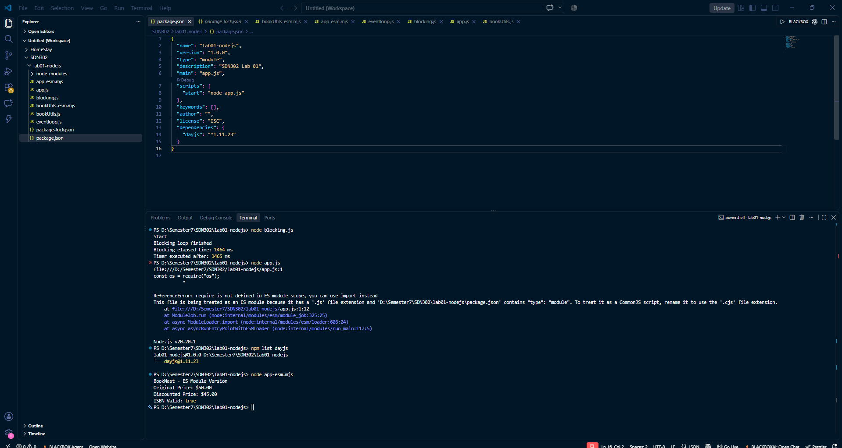

Requirement 4:
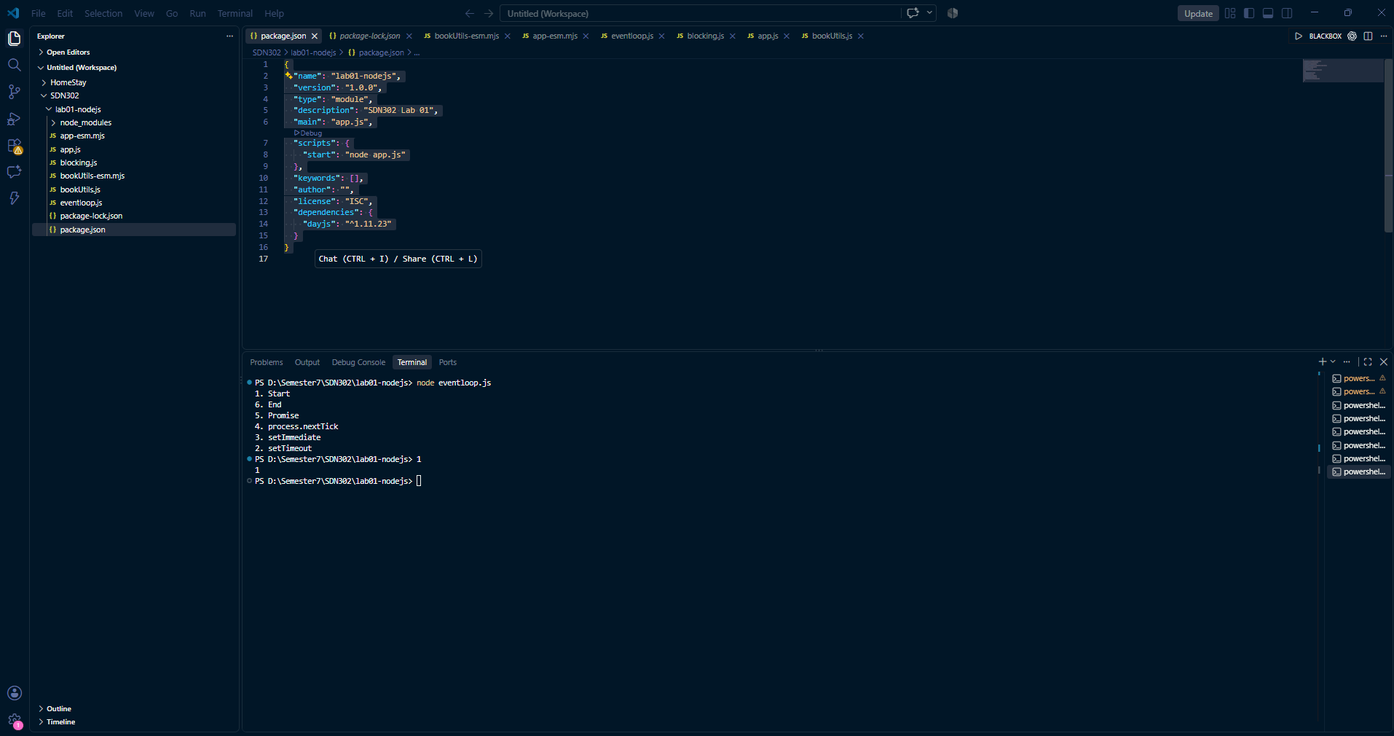
Requirement 5:
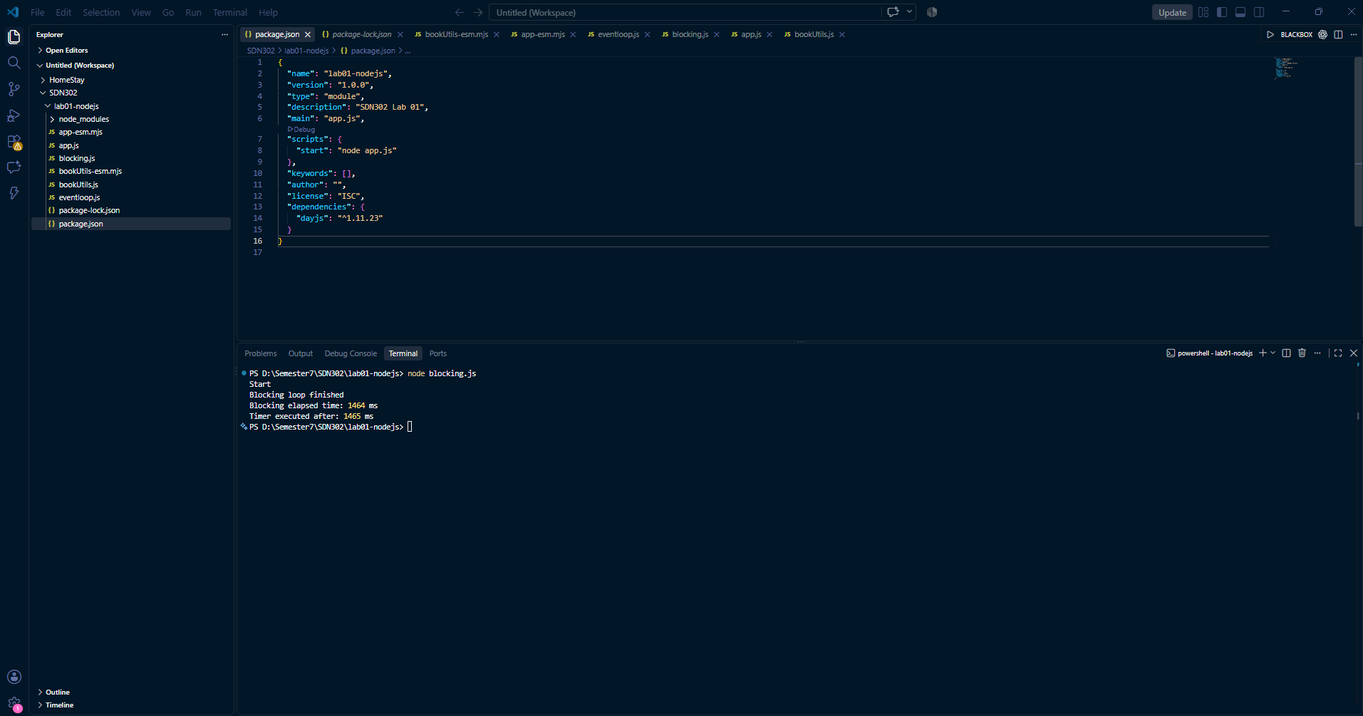
Web hosting is a service that provides infrastructure for deploying and serving a website or web application so that users can access it over the Internet.
Service Example: Vercel

CI/CD is a set of practices and automation processes used to continuously build, test and deploy software changes.
Example: GitHub Actions

